**Basic proposal – subsector and regional trends**

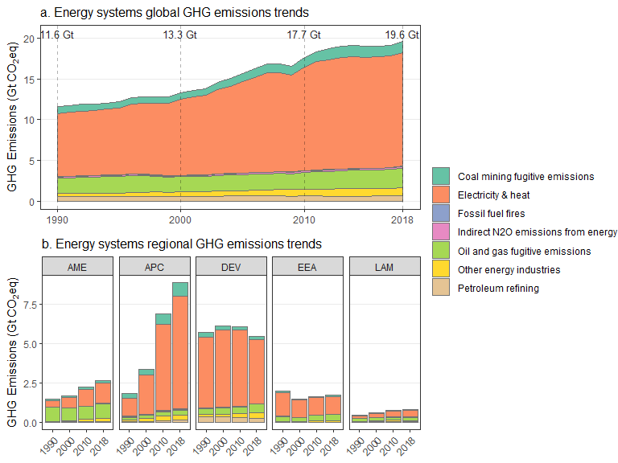

Could also include:

* Aggregate growth rates between 1990:2018 in panel a
* Shares of subsectors in panel a
* Indirect emissions as additional “subsectors” (buildings, industry)

**Additional options:**

* Kaya decomposition using sector CO2 and energy (global pop, gdp)
  + See section in Ch2 coordinated by Tommy Wiedmann
* Emissions by GHG

